Differences in the Morphology of Australian Lizards in an Arboreal Habitat

Sherwin Miller

Evolution

Dr. Mitchell

9th April 2020

**Abstract**

Adaptive radiation is an important topic in evolutionary biology and there are environmental factors that affect organisms such as lizards living in habitats. In this paper, two species of *Anolis* lizards and three species of *Cryptoblepharus* lizards in an arboreal habitat are used to determine if body parts between Australian lizards living in the same habitat are statistically different. The body parts that are examined are fore-limb length, snout-vent length, rear-limb length, head width, and ear to limb length. To determine this an ANOVA test was used in a programming language known as R for each body part between the species. Plots were created to look at the length and width of each body part between species. It was determined that the body parts between Australian lizards in an arboreal habitat are significantly different.

**Introduction**

Adaptive radiation is one of the central topics in evolutionary biology. Adaptive radiation is termed as an array of species that live in different environments with corresponding traits and results from the differentiation of a single common ancestor (Schulter D. 2000). There can be environmental factors affecting the habitat the lizard lives in. These environmental factors include temperature, predation, and resources. Temperature affects the life history of the lizard and its traits (Meiri et al. 2013). Temperature can also affect body size as well (Velasco et al. 2020).

There are different habitats that lizards live in such as arboreal, saxicolous, and littoral. Each of these habitats are similar and different. Arboreal habitats consist of organisms that live in trees. The structure of arboreal habitats affects the organism’s locomotion The organism’s locomotion in an arboreal habitat depends on the incline, length, and diameter of the perch (Mattingly and Bruce 2004). Saxicolous habitats consist of organisms that is living in rocks. Littoral habitats consist of organisms living near the shore area of lakes. These habitats offer resources that are available for many vertebrates and invertebrates. However, these habitats are affected negatively by human activities which causes an increase in nutritional loading, spreading invasive species, acidification, climate change, and increased fluctuation in water level (Peters and Lodge 2009).

Australia is home to many species of lizards including *Anolis* and *Cryptoblepharus*. Anolis and *Cryptoblepharus* lizards are both great for studying adaptive radiation. *Anolis* lizards are typically green, brown, or grey. They approximately weight 1- 10 grams and have a body length of 35-85 mm. The two traits that distinguish Anolis from other genera are expanded toepads and a dewlap which is an extensible colorful flap of skin that is attached to the throat (Losos and Schneider 2009). *Cryptoblepharus* lizards are defined by having a snake-eye appearance. These lizards are variable in color and have spectacles on their eyes instead of a moving eyelid (Vitt 2018).

This paper will look into the differences of body parts in the same type of habitat in the Australian lizards. The type of habitat that will be examined is an arboreal habitat. My hypothesis is that the body parts of Australian lizards living in the same type of habitat are significantly different.

**Materials and Methods**

To test this hypothesis, data was obtained from Blom et al. (2016) in Dryad and from Kolbe et al. (2016) in figshare. Dryad is an international repository that contains research data and data from scientific and medical publications. Figshare is a repository where researcher can submit their datasets, figures, images, and videos. Dryad and figshare are great places to get evolutionary data. The data from Blom et al. (2016) contains the species of the genus *Cryptoblepharus* along with their habitats and the length and width of their body parts. These habitats include saxicolous, littoral, and arboreal. Body parts include SVL (snout-vent length), FL (forelimb length), RL (rear-limb length), HL (Hind-limb length), SE (snout length), CHEEK (eye to ear length), NECK (ear to limb length), head height (HH), and head width (HW). The species that is used in this hypothesis for the *Cryptoblepharus* are *ruber, metallicus*, and *buchananii*. Data from Kolbe et al. (2016) contains two species of the *Anolis* genus along with their sex. The Anolis lizards from this dataset were living in arboreal habitats. The body parts of the Anolis lizards were measured in millimeters and their mass was measured in grams. Their body parts include SVL (snout-vent length), femur length, tibia length, 4th toe metatarsal length, 4th toe phalanges length, humerus length, ulna length, 3rd-toe metatarsal with phalanges length, head length, pectoral width, pelvis width, tail length, 3rd toe forefoot toepad, and 4th toe hindfoot toepad. For this hypothesis, snout-vent length, ear to limb length, rear-limb length, head width, and fore-limb length were used.

In order to test the significant differences of body parts between Australian lizards living in the same habitat, an ANOVA test was used in R. R is a programming language that is used by statisticians for data analyses (R Core Team 2019). Generally, ANOVA tests are only used when there are two or more variables. For snout-vent length and head width, *ruber, metallicus, buchananii, A. cristatellus*, and *A. stratulus* species were used. For fore-limb, rear-limb, and ear to limb length, *ruber, metallicus*, and *buchananii* were used. Tables 1-5 show the combined data for each body part with the corresponding species. Tables 1-5 were made by using the function cbind() by combining the species with their values in vectors and saving them in an object called Combined_Groups. Then, to make the ANOVA test work, the function stack() was used for the object Combined_Groups to stack the groups together and saved into a new object called Stacked_Groups. Next, to perform the ANOVA test, the function aov() was used for the object Stacked_Groups. Lastly, plots were made for figures 1-5 by using the plot() function.

**Results**

The ANOVA test for snout-vent length was calculated as df = 2, sum square = 16,563, mean square = 4141, F value = 134.1, and the p value = 2 x 10-16. The ANOVA test for head width was calculated as df = 4, sum square = 119.5, mean square = 299.9, F value = 301.2, and the p value = 2 x 10-16. The ANOVA test for fore-limb length was calculated as df = 2, sum square = 5.18, mean square = 2.588, F value = 1.761, and the p value = 0.176. The ANOVA test for rear-limb length was calculated as df = 2, sum square = 6.69, mean square = 3.343, F value = 1.442, and the p value = 0.24. The ANOVA test for ear to limb length was calculated as df = 2, sum square = 12.52, mean square = 6.260, F value = 7.986, and a p value of 0.000537. The species with the highest snout-vent length was *A. cristatellus* and the species with the lowest snout-vent length was *buchananii* (Figure 1 and Table 1). The species with the highest head width was *A. cristatellus* and the species with the lowest head width was *buchananii* (Figure 2 and Table 2). For forelimb length, *buchananii* was the highest and *ruber* was the lowest (Figure 3 and Table 3). For rear-limb length, the highest was *buchananii* and *ruber* was the lowest (Figure 4 and Table 4). Lastly, for ear to limb length, the highest was *metallicus* and the lowest was *ruber* (Figure 5 and Table 5).

|  |  |  |  |  |
| --- | --- | --- | --- | --- |
| *Ruber* | *Buchananii* | *Metallicus* | *A.cristatellus* | *A.stratulus* |
| Min. :26.38 | Min. :28.37 | Min. :31.45 | Min. :40.50 | Min. :35.50 |
| 1st Qu. :33.96 | 1st Qu. :34.46 | 1st Qu. :38.42 | 1st Qu. :47.12 | 1st Qu. :40.50 |
| Median :35.85 | Median :38.07 | Median :39.85 | Median :51.00 | Median :44.00 |
| Mean :35.48 | Mean :37.18 | Mean :40.71 | Mean :55.55 | Mean: 42.92 |
| 3rd Qu: 37.65 | 3rd Qu. :39.60 | 3rd Qu. :43.92 | 3rd Qu. :65.38 | 3rd Qu :46.00 |
| Max. :40.78 | Max. :46.60 | Max. :47.24 | Max73.00 | Max. :49.00 |

**Table 1.** *Combined data of Australian lizards for snout-vent length*.

|  |  |  |  |  |
| --- | --- | --- | --- | --- |
| *Ruber* | *buchanani* | *metallicus* | *A.cristatellus* | *A.stratulus* |
| Min. :3.340 | Min. :3.880 | Min. :4.490 | Min. :6.927 | Min. :5.599 |
| 1st Qu. :4.407 | 1st Qu. :4.190 | 1st Qu. :4.795 | 1st Qu. :7.907 | 1st Qu. :6.167 |
| Median :4.560 | Median :4.525 | Median :5.050 | Median :9.319 | Median :6.826 |
| Mean :4.601 | Mean: 4.589 | Mean :5.095 | Mean : 9.63 | Mean :6.640 |
| 3rd Qu. :4.890 | 3rd Qu. :4.830 | 3rd Qu. :5.270 | 3rd Qu. :11.763 | 3rd Qu. :7.166 |
| Max. :5.560 | Max. :5.970 | Max. :6.640 | Max. :13.048 | Max. :7.838 |

**Table 2.** *Combined data of Australian lizards for head width.*

|  |  |  |
| --- | --- | --- |
| *Ruber* | *buchananii* | *metallicus* |
| Min. :9.35 | Min. :10.70 | Min. :10.73 |
| 1st Qu. :13.11 | 1st Qu. :13.04 | 1st Qu. :13.27 |
| Median :13.68 | Median :14.01 | Median :14.06 |
| Mean :13.46 | Mean :13.88 | Mean :13.89 |
| 3rd Qu. :14.11 | 3rd Qu :14.86 | 3rd Qu. :14.60 |
| Max. :15.04 | Max. :16.46 | Max. :15.83 |

**Table 3**. *Combined data of Australian lizards for Fore-limb length*

|  |  |  |
| --- | --- | --- |
| *Ruber* | *buchananii* | *metallicus* |
| Min. :12.07 | Min. :12.31 | Min. :12.25 |
| 1st Qu. :16.33 | 1st Qu. :16.05 | 1st Qu. :16.26 |
| Median :16.84 | Median :17.34 | Median :16.96 |
| Mean :16.59 | Mean :17.14 | Mean :16.83 |
| 3rd Qu :17.25 | 3rd Qu. :18.04 | 3rd Qu. :17.89 |
| Max. :18.82 | Max. :21.12 | Max. :18.78 |

**Table 4**. *Combined data of Australian lizards for Rear-Limb length*

|  |  |  |
| --- | --- | --- |
| *ruber* | *buchananii* | *metallicus* |
| Min. :5.590 | Min. :6.000 | Min. :6.930 |
| 1st Qu. :7.298 | 1st Qu. :7.438 | 1st Qu. :8.207 |
| Median :8.055 | Median :7.960 | Median :8.490 |
| Mean :7.840 | Mean :7.985 | Mean: 8.553 |
| 3rd Qu. :8.505 | 3rd Qu. :8.672 | 3rd Qu. :8.947 |
| Max. :9.980 | Max. :9.960 | Max. :10.100 |

**Table 5**. *Combined data of Australian lizards for ear to limb length*

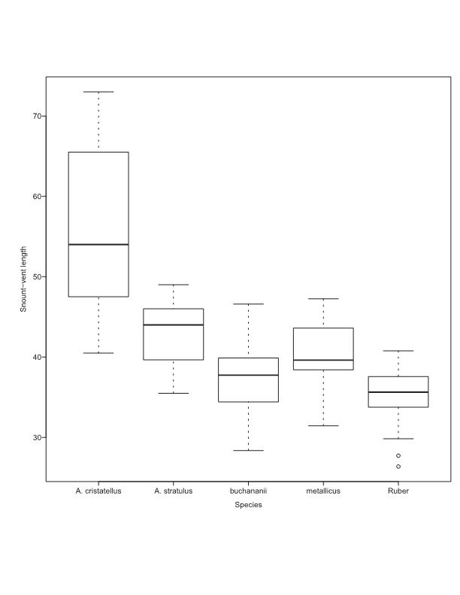

**Figure 1.** *Species vs. Snout-Vent Length* **Length**

**Figure 2.** *Species vs. Head Width*

**Figure 3.** *Species vs. Fore-limb length*

**Figure 4.** *Species vs. Rear-limb length*

**Figure 5.** *Species vs. ear to limb length*

**Discussion**

Based on the results, fore-limb length, head width, rear-limb length, ear to limb length, and snout-vent length are all significantly different between species. This was determined by the F value being greater than the p value. Although each of these species live in the same habitat with the same climate, resources, and predation, it is reasonable that there are differences in body parts as some lizards are longer and wider than others. Some differences of their body parts could be related to the morphology and function of their genus. It could also be that some of the lizards were younger. Another reason is it could be due to the body mass of the lizards. However, the datasets did not contain the ages of the lizards and only one dataset contained body mass from *Anolis* and not the *Crytoblepharus*. In conclusion, based on the results from the ANOVA tests, body parts between Australian lizards in the same type of habitat are significantly different.

**Works Cited**

Blom, Mozes P K et al. “Convergence across a continent: adaptive diversification in a recent radiation of Australian lizards.” *Proceedings. Biological sciences* vol. 283,1832 (2016): 20160181.

Kolbe, Jason J, et al. “City Slickers: Poor Performance Does Not Deter Anolis Lizards from Using Artificial Substrates in Human‐Modified Habitats.” *Functional Ecology*, vol. 30, no. 8, 2016, pp. 1418–1429.

Losos JB, and Schneider CJ. “Anolis Lizards.” *Current Biology: Cb*, vol. 19, no. 8, 2009, pp. 316–8.

Mattingly, W. Brett, and Bruce C Jayne. “Resource Use in Arboreal Habitats: Structure Affects Locomotion of Four Ecomorphs of Anolis Lizards.” *Ecology*, vol. 85, no. 4, 2004, pp. 1111–1124.

Meiri, Shai, et al. “Are Lizards Feeling the Heat? A Tale of Ecology and Evolution Under Two Temperatures.” *Global Ecology and Biogeography*, vol. 22, no. 7, 2013, pp. 834–845.

Peters, J.A, and D.M Lodge. “Encyclopedia of Inland Waters.” *Littoral Zone*, 2009, pp. 79–87.

Schluter D. 2000. The ecology of adaptive radiation. Oxford, UK: Oxford University Press.

R Core Team (2019). R: A language and environment for statistical computing. R Foundation for Statistical Computing, Vienna, Austria. https://www.R-project.org/.

Velasco Julián A, et al. “Macroecology and Macroevolution of Body Size in Anolis Lizards.” *Ecography*, (20200213), 2020.

Vitt, Laurie. “Skink.” Encyclopædia Britannica, 10, Oct. 2018, <https://www.britannica.com/animal/skink>.